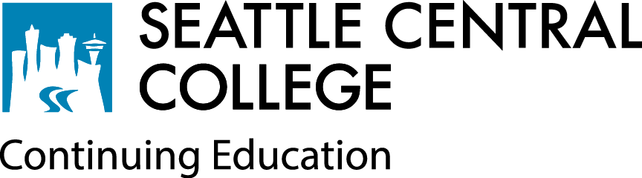

Continuing Education

Underage Student Release Form

I __________________________________________________ as the parent or legal guardian of

(Print name of parent or legal guardian)

______________________________________, _______ understand that she/he will be enrolled in

(Print underage student’s name) (Age)

courses designed for adults and I/my child understand that these courses will not be altered base on the presence of an underage student in the classroom. I, on behalf of myself and my child acknowledge the risks that my child will be exposed to and agree to allow participation in these classes at my own/my child’s own risk. I release Seattle Central College and college employees of any and all liability that may arise as a result of my child attending this college course. I understand Continuing Education’s underage policy and agree to register and attend class with my child and accompany them at all times while on campus if they are under 16.

Signature: __________________________________________

Printed Name: _________________________________________

Date: _______________________________________________

Please email form to [Conted.Central@seattlecolleges.edu](mailto:Conted.Central@seattlecolleges.edu).